Agent Based Modelling for simulating the Interregional Patient Mobility in Italy

Fabrizio PECORAROa,[1], Filippo ACCORDINOa, Federico CECCONIb and Mario PAOLUCCIa,b

a Institute for Research on Population and Social Policies, National Research Council. Rome, Italy

b Institute of Cognitive Sciences and Technologies, National Research Council. Rome, Italy

ORCiD ID: Fabrizio Pecoraro <https://orcid.org/0000-0001-5718-4240>

**Abstract.** Patient mobility is considered one of the main concerns for policy-makers as it impacts financial sustainability of regional health systems affected by the high percentage of patients accessing care services in other regions. For a better understanding of this phenomenon it is necessary to define a behavioral model able to model the interaction of the patient with the health system. In this paper to accomplish this task we adopted the Agent-Based Modelling (ABM) approach for simulating patient flow across the Italian regions and determining which are the main factors influencing it. This may provide a new insight into this phenomenon providing an input for policy makers to capture to what extent quality of services may contribute to contain patient mobility.

**Keywords.** Patient mobility, Agent-Based Modelling, Italy, Spatial accessibility, Simulation process

# Introduction

Patient mobility is considered as a proxy to appraise the quality and availability of hospital services [1] and to point out socio-economic disparities at local and regional level [2]. Different studies have underlined the main characteristics of this phenomenon [1], including demographic and socio-economic status [3], quality and complexity of local services [4] and structural components [5]. Among them two inter-related aspects affect patient mobility: accessibility and availability of intra- and inter-regional facilities in particular for patients living at the regional borders [6]. In Italy, mitigating passive mobility is one of the main action at the basis of the Health Pact 2019–2021 signed by the Conference of Regions and Autonomous Provinces. This document highlights the necessity of mapping patient flows and drawing up a “plan to stop” passive mobility, with particular attention on critical sectors [1]. For further understand this phenomenon and capturing which are the main factors influencing patient’s choice, it is necessary to define a behavioral model that includes a variety of individual, community and socio-economic characteristics that represent the patient-system interaction. In different complex settings among which healthcare, this is done using Agent-Based Modelling (ABM) approach [7]. ABM is able not only to synthesize prior knowledge of a population and effectively represent and simulate this interaction [8], but also to understand how an intervention could modify the dynamics of patient behavior and affect public health [9]. Within this context, aim of this study is to design and propose an ABM approach for simulating patient flow across the Italian regions and determining which are the main factors influencing it. The suitability of this approach in this specific setting is tested considering both the accuracy and procession of the simulation process. The application of a robust ABM may provide a new insight into this complex phenomenon by scaling the mathematical model from an abstract (i.e. region) to a more refined level (i.e. patient). This allows to significantly describe the interaction of a patient with the health system. Moreover, it may provide an input for policy makers to capture to what extent capacity, quality and distribution of structures and services may contribute to the reduction of patient passive mobility.

# Materials and methods

## Data collection and identification of factors

Data on hospitals and mobility was gathered from the Ministry of Health website [10] and from the National Outcomes Program website [11], while demographic data was collected from the Italian National Institute of Statistics (ISTAT) website [12]. All data refers to the year 2019. From a clinical perspective, this study focuses on the hip replacement surgery procedure, an elective treatment where patients are generally prepared to travel long distances beyond their nearest provider [13]. To identify which variables mostly impact patient mobility, we applied the best subsets regression function of R (i.e. *regsubsets*) that tests all possible combinations of the predictor variables and then selects the best model according to the highest adjusted R squared value. The resultant regression model is reported in Equation 1 (note that adjusted-R2 = 0.66 and all variables are statistically significant, p < 0.05).

${stay}_{\%}=42-0.05w+0.6s+0.07{int }_{intra}-50{ret}_{intra}+0.3{bed}_{intra}$ (1)

where ${stay}_{\%}$ is the probability that the patient is cared in his/her region of residence, *w* is the number of days a patient has to wait for accessing the service (at regional level), *s* is the level of patient satisfaction due to the last hospital admission (at regional level), while ${int }_{intra}$, ${ret }_{intra}$ and ${bed }_{intra}$ describe, respectively, the number of interventions, the percentage of patients returned to hospital in the following 2 years from the intervention and the number of beds available in the orthopedics wards. Note that further indicators such as those specifically related to the patient (i.e. income, education) have been discarded from the model as they were not statistically significant. Hospital-related indicators have been computed (for each municipality *i*) adopting Equation 2 based on a gravity model which relates the increasing probability to access to a hospital with its capacity, quality and distance:

${int}_{intra}^{i}=\sum_{j∈\{Reg\left(i\right)=Reg\left(j\right)\}}{R_{j}w_{i,j}}=\sum_{j∈\{Reg\left(i\right)=Reg\left(j\right)\}}{\frac{{INT}_{j}}{\sum_{i}{{pop}_{i}*w_{i,j}}}}w_{i,j}$ (2)

where $R_{j}$ represents the weighted hospital-to-population index of hospital *j, ${INT}_{j}$* is the number of interventions carried out in hospital *j* and ${pop}_{i}$ is the resident population of the municipality *i*. $w_{i,j}$ that represents the weighting distance between the hospital *j* and the municipality *i* has been computed using the Sigmoid decay function. Based on Equation 2, an average value weighted by population of each indicator has been computed at province level. For further details please see [14].

## Simulation process description

Figure 1 shows the main steps of the ABM simulation process. A set of 100000 individuals are extracted from the whole target population using a stratified random sampling methodology considering two risk factors: age and gender. The second step (i.e. simulation) is composed by three activities: 1) a set of 1000 patients are extracted from the sample population to define the group of patients that need to be cared in a specific loop; 2) selected patients and hospitals are placed over the patches of the environment; 3) one patient at time is randomly picked up from the 1000 patients and the mobility index (see Equation 1) is computed to assess the probability that the patient travels outside his region to be cared. On the basis of this index and the accessibility of hospitals available over the territory, the ABM simulation process stochastically determines the structure chosen by the patient. The simulation process is executed 52 times to model the access to care as a weekly procedure considering that the average length of stay for the primary total hip replacement is around 7 days [15].

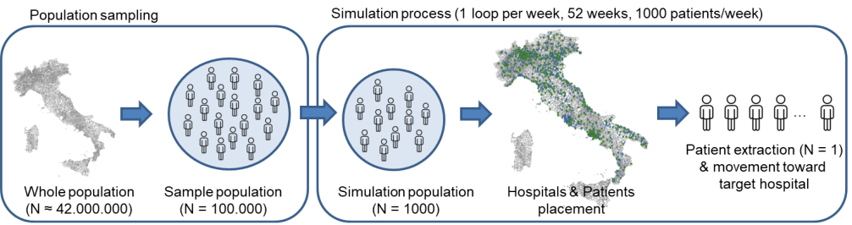

**Figure 1.** Agent-based modelling simulation process

To capture the accuracy (i.e. reproducibility) and the precision (i.e. repeatability) of the model five repeated sessions has been executed. From a statistical perspective, accuracy was assessed using the regression coefficient between the simulated data and the original data, while precision was assessed using the Intraclass Correlation Coefficient (ICC(2,1)) to capture the intra-session reliability between observations.

# Results

Figure 2 shows the Netlogo environment: on the left side the interface items adopted to control agents and the system are reported. In particular, the *n_ticks* and *n_patients* inputs allow to set, respectively, the number of weeks and the number of patients per week to be involved in the simulation. The output *patients_to_be_placed* facilitates the supervision of the status of the process capturing the total number of patients located over the environment that has not been cared yet. On the right side of the window the Netlogo environment integrates the representation of the Italian territory divided by municipalities, colored depending on the passive mobility percentage. A specific legend is also reported to easily interpret the distribution of this index over the territory.

The scatterplot diagram reported in Figure 3 highlights the linear regression coefficient and model between the passive mobility gathered from the ABM simulation (x-axis) and the passive mobility computed with the multiple linear regression model (y-axis). As clearly reported by R2 (> 0.98) there is a very strong direct relationship between these two variable. A high correlation (R2 > 0.66) is also reported considering the linear regression between the simulation mobility and passive mobility computed with the real hospital values. This result confirms the goodness of the simulation model. Considering the precision, the ICC(2,1) computed carrying out five sessions of ABM simulation resulted higher than 0.95 confirming the repeatability of the process.

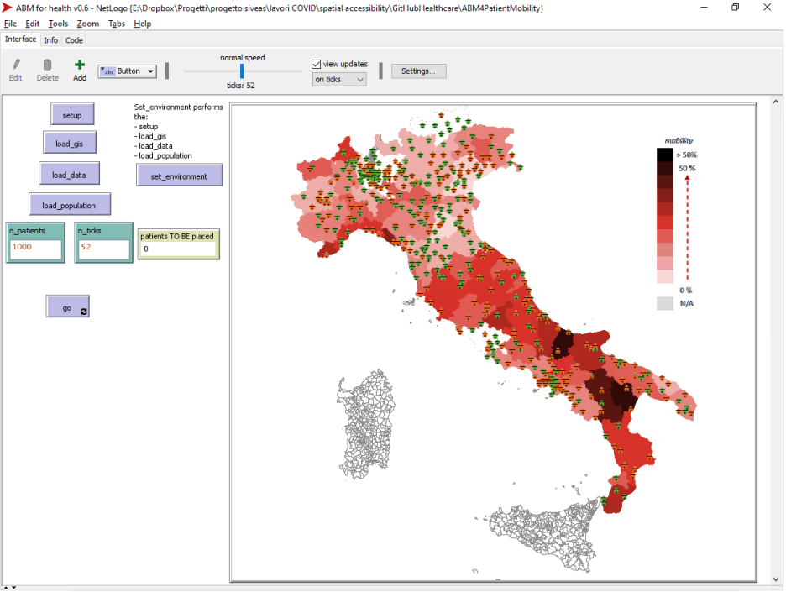

**Figure 2.** Netlogo environment highlighting the preliminary results of one simulation session

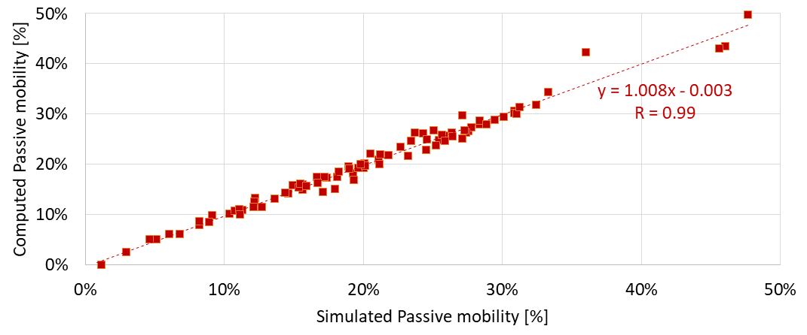

**Figure 3.** Correlation between the passive mobility gathered from the simulation model (x-axis) and the passive mobility computed with the multiple linear regression model (y-axix)

# Discussion and conclusions

This paper provides an ABM approach that starting from the information gathered at individual, hospital and local level determines the probability that a patient accesses to extra-regional services for a hip transplant surgery procedure. To accomplish this task we firstly defined a mathematical model able to accurately describes the dynamics of the patient-system interaction and defines the probability that each patient involved in the simulation process accesses to an inter-regional structure. Based on this model, ABM stochastically determines the level of attraction of each structure and simulates the patient flows across the Italia regions. Preliminary results of the applicability of this approach highlight a high precision and accuracy in the description of patient mobility. This is clearly evident considering the very strong correlation coefficient between the simulated and the computed passive mobility. Moreover, the repeatability of the process is also confirmed by analyzing the low inter-session variability reported by the ICC. This high level of accuracy and precision confirms the goodness of the ABM simulation approach to describe this specific scenario. In this paper, we applied this methodology considering the hip replacement surgery procedure. However, this can also be applied to other elective surgery or curative services, to primary care services, or even to acute care services, such as intensive care. Of course, the scalability of this methodology requires a robust mathematical model able to describe the dynamics of the patient-system interaction.

The results reported in this paper focus on a real patient passive mobility scenario based on a prior knowledge of a population. Future works will detail the mathematical model to further analyze the main factors at individual, local and regional level responsible for attracting patients and contribute to active mobility. Moreover, simulation basic variables will be updated to verify how these changes may impact on patient mobility. This may help policy makers and hospital administrative professionals to capture to what extent these changes may help to contain this dynamics. For instance this can be done by reducing the waiting times, improving the number of beds available or even providing an additional points of care in a specific part of the territory that, for instance, is not reached by the service under investigation.

References

1. Nante N, Guarducci G, Lorenzini C, Messina G, Carle F, Carbone S, Urbani A. Inter-Regional Hospital Patients’ Mobility in Italy. Healthcare. 2021; 9(9): 1182.
2. Ricci A, Barzan E, Longo F. How to identify the drivers of patient inter-regional mobility in beveridgean systems? Critical review and assessment matrix for policy design & managerial interventions. Health Services Management Research. 2021; 34(4): 258-268.
3. Mafrolla E, D’Amico E. Patients’ mobility as an indicator for (in)efficiency: a panel data analysis on Italian health care authorities. Health Econ Rev. 2013; 3:3.
4. De Curtis M, Bortolan F, Diliberto D, Villani L. Pediatric interregional healthcare mobility in Italy. Italian Journal of Pediatrics. 2021; 47(1): 1-7.
5. Balia S, Brau R, Marrocu E. Interregional patient mobility in a decentralized healthcare system. Regional Studies. 2018; 52(3): 388-402
6. Pecoraro F, Luzi D, Clemente F. Spatial Inequity in Access to Intensive Care Unit Beds at Regional Level in Italy. Studies in Health Technology and Informatics. 2021; 281: 809-813.
7. Tracy M, Cerdá M, Keyes KM. Agent-Based Modeling in Public Health: Current Applications and Future Directions. Annu Rev Public Health. 2018; 39: 77–94.
8. Steinbacher M, Raddant M, Karimi F. et al. Advances in the agent-based modeling of economic and social behavior. SN Bus Econ. 2021; 99.
9. Marshall B. Agent-based modelling. In: El-Sayed AM, Galea S, editors. Systems science and population health. Oxford: Oxford University Press; 2017. p. 29–51
10. Ministry of Health. National healthcare service database. 2022. Available from: [www.salute.gov.it/portale/documentazione/p6_2_8_1_1.jsp?lingua=italiano&id=6](http://www.salute.gov.it/portale/documentazione/p6_2_8_1_1.jsp?lingua=italiano&id=6)
11. National Agencies for Regional Health Services (AGENAS). National Healthcare Outcomes Program. Available. 2022. from: <https://pne.agenas.it/>
12. Italian National Institute of Statistics (ISTAT). Available from: <https://www.istat.it/it/archivio/222527>
13. Berta P, Guerriero C, Levaggi R. Hospitals’ strategic behaviours and patient mobility: Evidence from Italy. Socio-Economic Planning Sciences. 2021: 101030.
14. Pecoraro, F., Luzi, D., & Clemente, F. (2022). The Impact of Hospital Accessibility on Interregional Patient Mobility in Italy. Studies in Health Technology and Informatics, 294, 684-688.
15. Foote, J., Panchoo, K., Blair, P., & Bannister, G. (2009). Length of stay following primary total hip replacement. The Annals of The Royal College of Surgeons of England, 91(6), 500-504.

1. Fabrizio Pecoraro, IRPPS-CNR, Via Palestro, 32, 00185 Rome, Italy (f.pecoraro@irpps.cnr.it)